**Internship Project Report**

**Submitted by**: Khushi Bihani

**Internship Organization**: InnoByte Services

**Duration**: September 20th, 2025 - October 20th, 2025

**Date of Submission**: [DD/MM/YYYY]

# **Amazon Sales Report**

# Objective:

The purpose of this project is to analyze Amazon sales data in order to understand:

* Overall performance
* Customer behavior
* Product popularity
* Fulfillment efficiency
* Geographical distribution

The analysis will provide actionable insights to optimize sales strategies, enhance customer satisfaction, and improve business performance.

# Dataset Description:

* The dataset used for analysis has **[73699] rows and [21] columns** after cleaning.
* Key features include:

**['index', 'Order ID', 'Date', 'Status', 'Fulfilment', 'Sales Channel',**

**'ship-service-level', 'Category', 'Size', 'Courier Status', 'Qty',**

**'Amount', 'ship-city', 'ship-state', 'ship-postal-code', 'ship-country',**

**'B2B', 'fulfilled-by', 'Year', 'Month', 'Order_Month']**

* The original dataset contained missing values, duplicates, and inconsistent entries, which were removed or corrected during data cleaning.

# Methodology :

* Loaded the dataset **(Amazon Sale Report.csv)** into Python.
* Handled missing values and corrected data types.
* Performed Exploratory Data Analysis (EDA):
* Created visualizations using Matplotlib & Seaborn : Bar charts, pie charts, line charts, stacked bars
* Drew key insights and patterns from the analysis.

# Analysis & Results:

* **Sales Overview**
  + **Total Sales:** 45020255.93
  + **Monthly/Yearly Trends:**
    - **Peak Periods:** [2022-04 with highest sales]
    - **Low Periods:** [2022-06 with lowest sales]

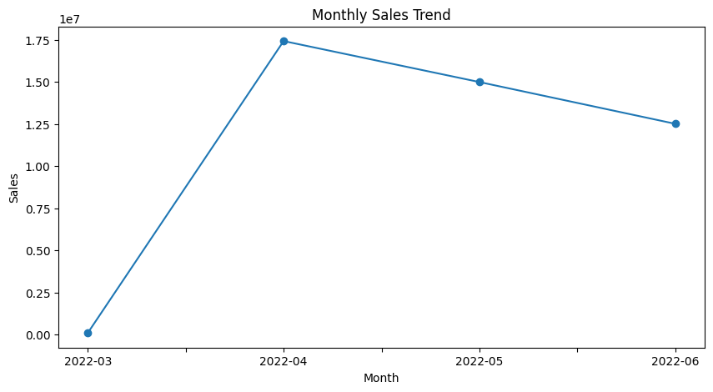

* **Product Analysis**
  + Top 3 Categories: T-shirt, Shirt, Blazzer
  + Popular Sizes: M,L
  + Low-selling Products: Shoes (category), Free size (size)

## 

* **Fulfillment Analysis**
  + **Fulfillment Methods Used:** [Easy Ship, Other]
  + **Delivery Success:**
    - **Delivered (Shipped):** Majority of the orders fall under “Shipped,” showing strong delivery performance.
    - **Pending (Unshipped + On the Way):** A small portion of orders are still unshipped or in transit.
    - **Returned (Cancelled):** Negligible share of orders are cancelled/returned.

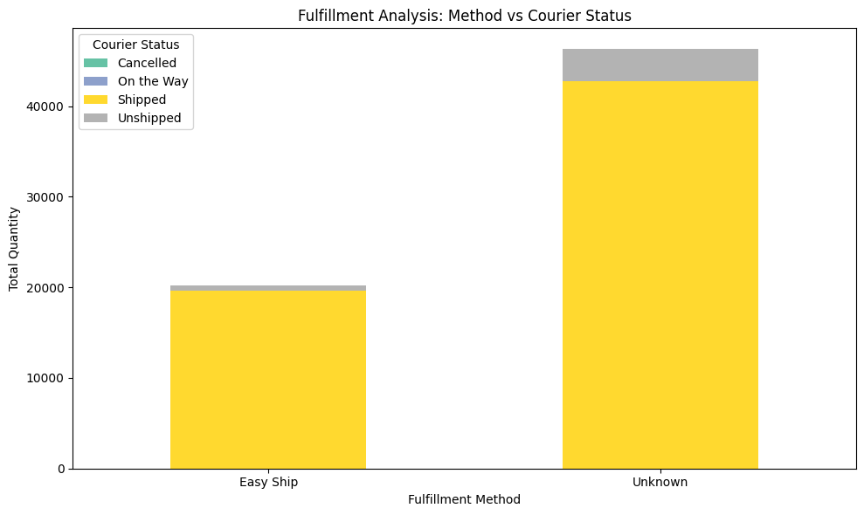

* **Customer Segmentation**
  + B2B vs B2C Distribution**:**[Insert insights → e.g., *B2C accounts for 70% of sales, while B2B contributes 30%.*]
  + 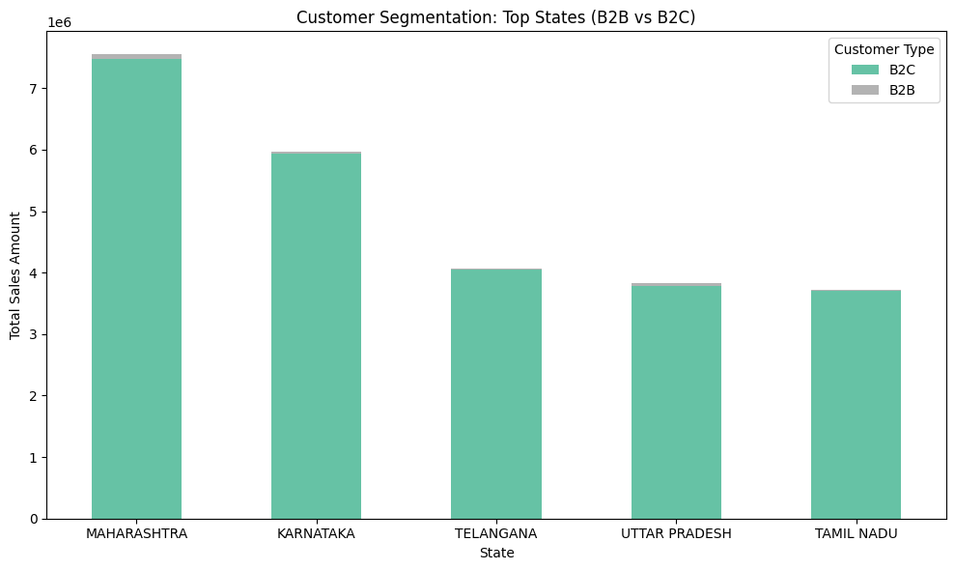Top States by Sales**:** Maharashtra, Karnataka, Telangana
* **Geographical Analysis**
  + **Top States by Sales:** Maharashtra, Karnataka, Telangana
  + 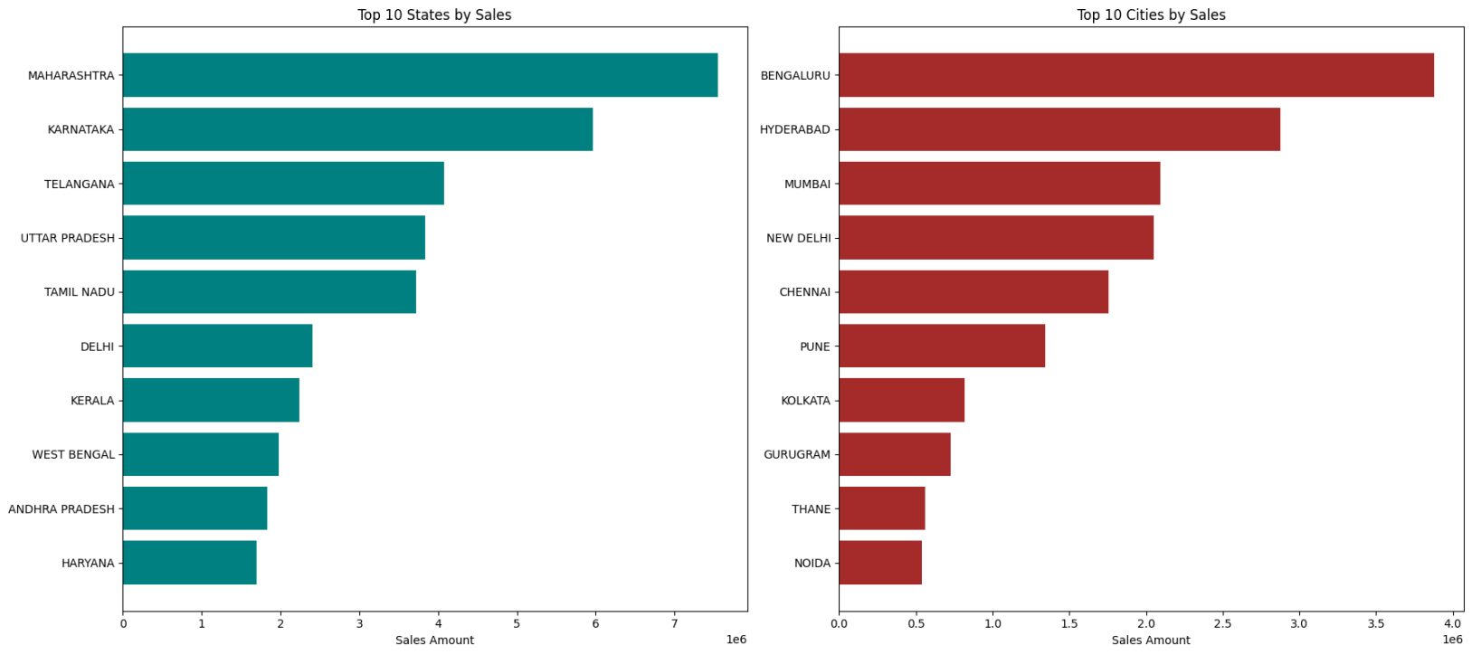**Top Cities by Sales:** Bengaluru, Hyderabad, Mumbai

# VisualizationusingPowerBI:

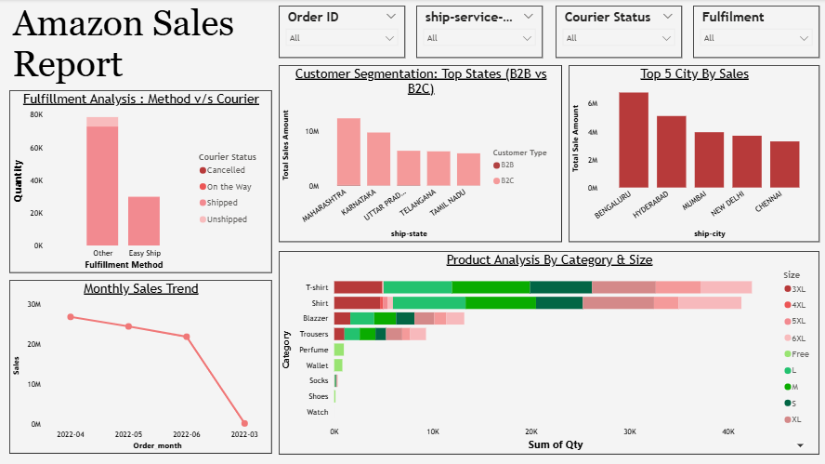An interactive dashboard was designed in Power BI to summarize and visualize the dataset. The dashboard includes KPIs, charts, and slicers that allow users to explore sales performance, customer segments, and regional distribution effectively.

## Insights & Conclusion

* **Action on Fulfillment**: “Other” method handles most orders—optimization here can boost efficiency.
* **Focus States/Cities**: Maharashtra & Bengaluru are top markets—ideal for targeted marketing and inventory planning.
* **Seasonality**: Monitor reasons for the sales decline after April 2022.
* **Product Strategy**: T-shirts/Shirts are clear best-sellers—consider expanding SKUs or premium options.
* **Size Inventory**: Stock M & L more aggressively to match demand.

## Final Conclusion & Learnings

From this project, I gained hands-on experience in data cleaning, analysis, visualization. I learned how to extract insights, build dashboards using Power BI, and prepare reports that highlight meaningful patterns. These projects helped me improve my technical as well as analytical thinking skills, which are essential for a Data Analyst role.